
Skagit Valley College Cash Advance Creation
Table of Contents

How to Create a Cash Advance----------------------------------------------------- 2
Directions------------------------------------------------------------------------------ 2
Part 1: Creating a Cash Advance with a Travel Authorization---------------- 2
Part 2: Creating a Cash Advance from the Navigation Bar--------------------- 8
Returning Unused Cash Advance Funds----------------------------------------- 13

How to Create a Cash Advance

This guide will show you how to create a Cash advance with a Travel authorization in Part 1 and, in Part 2, how to create a cash advance from the Navigation Bar (NavBar). Cash Advances are not required for travel. First, a few tips:
- Your screen may look different than the images you see in this guide. The number of tiles you see and the options you have on the menu will depend on your role at the college.
- The SVC IT Helpdesk, ITHelpdesk@skagit.edu, can help if you have problems with sign-in credentials, usernames, or passwords.
- The Travel Administrator, Miranda Brown, can assist you with errors or questions directly relating to filling out the Expense Report.

Cash advances are only given if:
- The total is $100 or more
- There is an approved Travel Authorization for the same trip.
- It is less than 30 days to departure

Directions
Part 1: Creating a Cash Advance from a Travel Authorization
Steps 1–8 show you how to navigate to the page to begin creating or modifying a travel authorization. If you are familiar with ctcLink navigation, here is the shorthand version: From the ctcLink Gateway, click FSCM (or Financials Self-Service) > NavBar > Navigator > Employee Self-Service > Travel and Expenses > Travel Authorizations > Create/Modify

- Log in to ctcLink.
- Click FSCM (Financial Supply Chain Management) from the top of the window or Financials Self-Service on the left navigation.
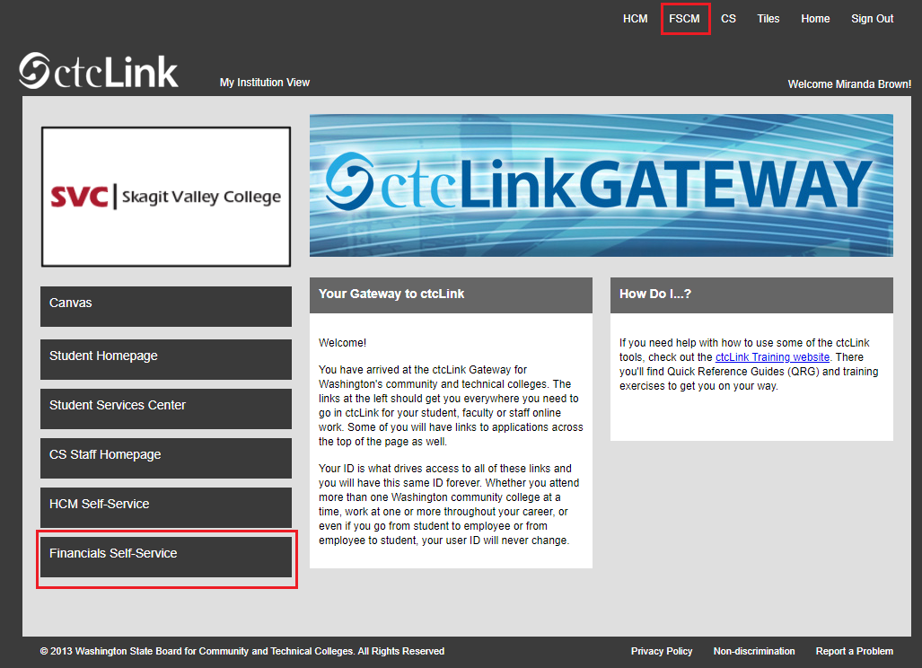

- Click the Navigation Bar (NavBar) button in the top right corner — indicated by the compass icon — to view the NavBar tiles.
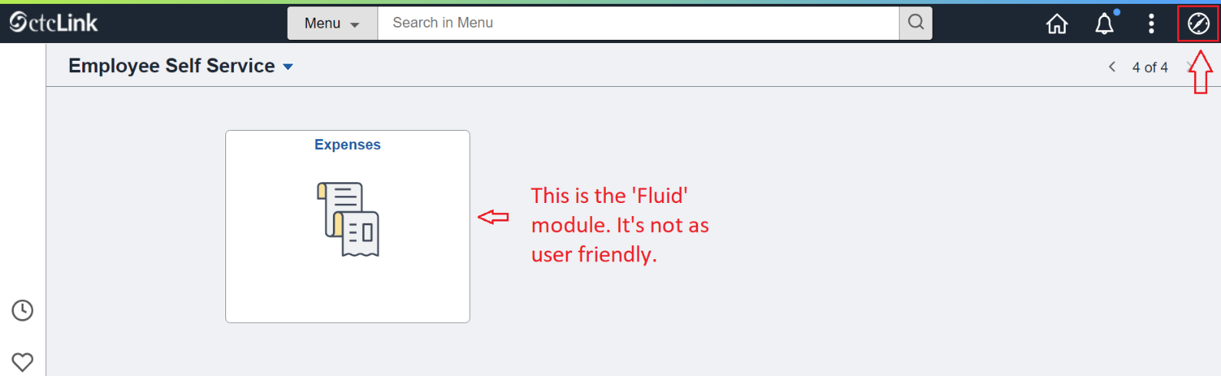

- The NavBar tiles will display. Click the Menu tile.
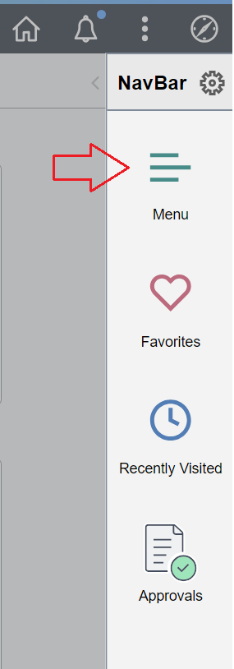
- The Secondary Level Content menu will display. Click Employee Self-Service.
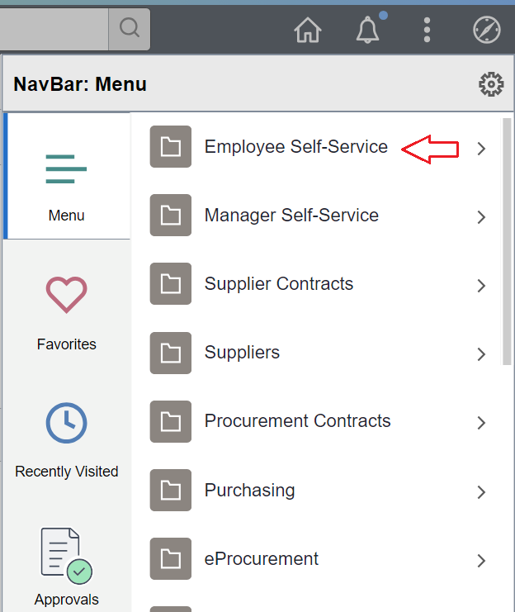

- The Employee Self-Service menu will be displayed. Click Travel and Expenses.
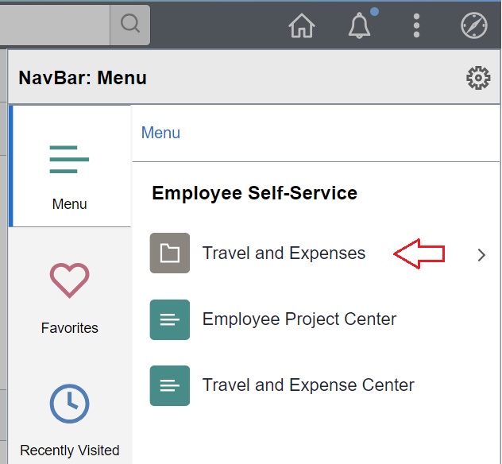

- The Travel and Expenses menu will display. Click Travel Authorizations.
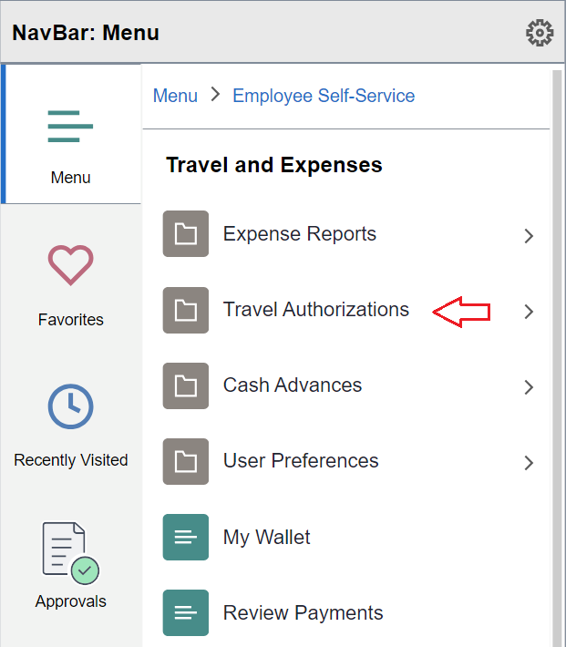

- The Travel Authorizations menu will be displayed. Click Create/Modify.
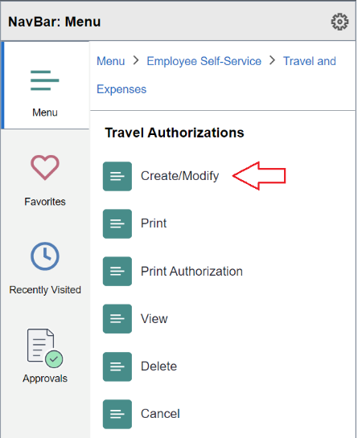

- While you’re in the process of creating a Travel Authorization, you can click the Actions drop down and select Create Cash Advance. Select GO.

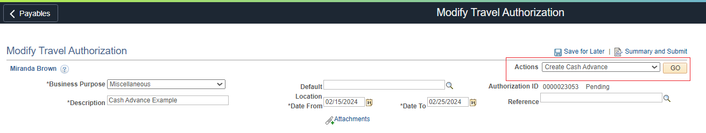
Your Business Purpose and Advance Description will auto-populate based on what you entered in the Travel Authorization. Please note that you do not need to separate your lines by meal or day; one-line total is sufficient.
Source – System Check
Description – Any description here is good (total meal expenses, hotel advance, etc)
Amount – The total amount requested
Accounting Details – All cash advances are required to use the same clearing account budget regardless of where the funds originate.
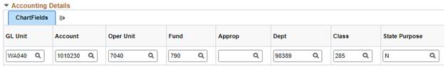
- Check the box and select Submit Cash Advance.
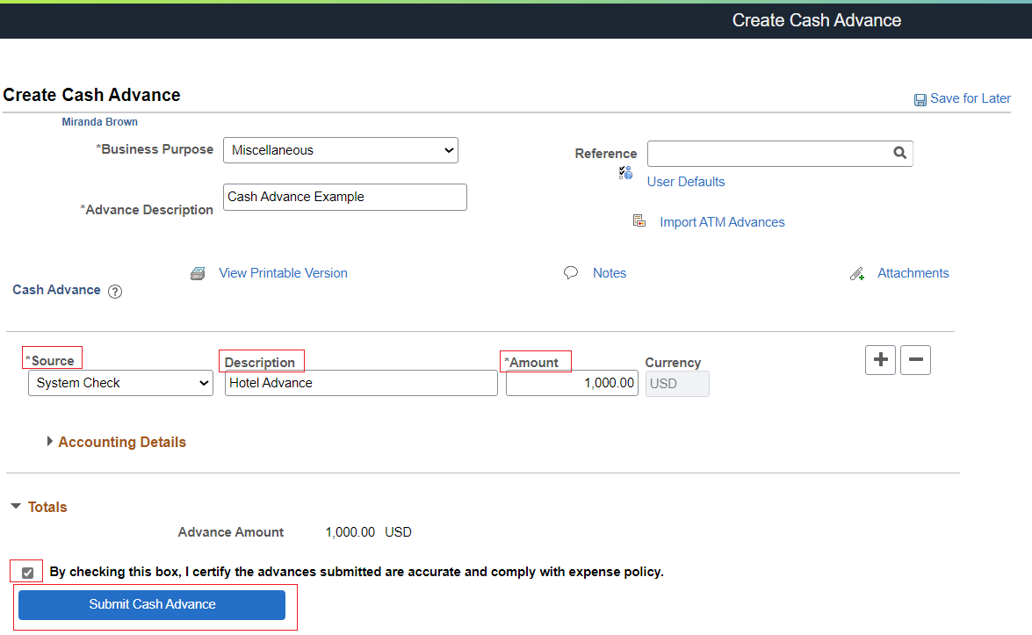
- If there are no errors in the cash advance, you will see a pop-up asking to confirm. Select OK.
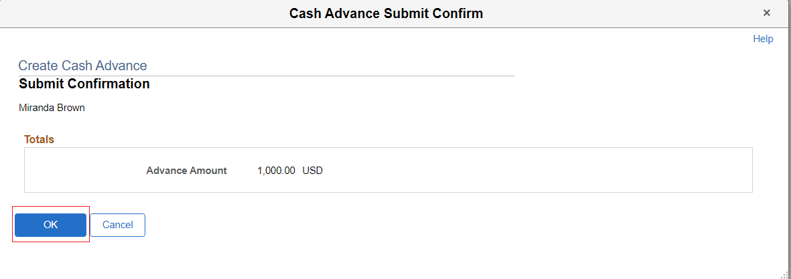
Success! You are done submitting your cash advance. You will need to go back and finish submitting your Travel Authorization.

Part 2: Creating a Cash Advance Through the NavBar

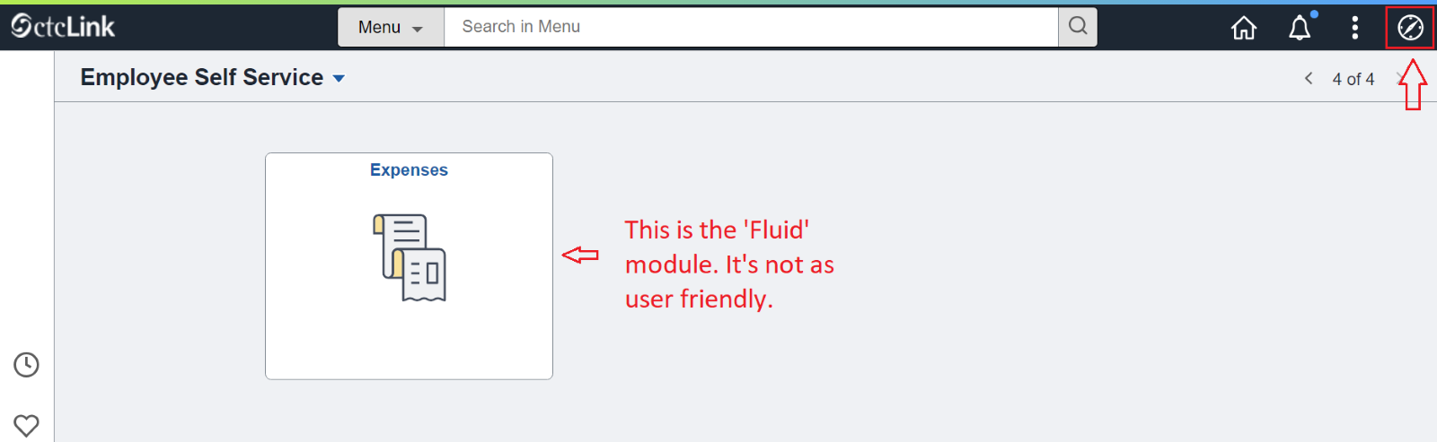
- Click the Navigation Bar (NavBar) button in the top right corner — indicated by the compass icon — to view the NavBar tiles.

- The NavBar tiles will display. Click the Menu tile.

- The Secondary Level Content menu will display. Click Employee Self-Service.
- The Employee Self-Service menu will be displayed. Click Travel and Expenses.

- The Travel and Expenses menu will display. Click Cash Advances.
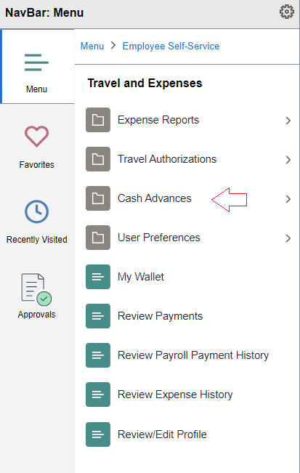
- Click Create/Modify
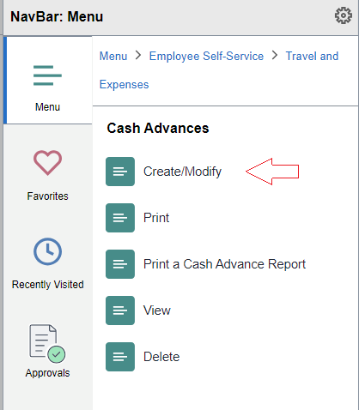

- The Cash Advance page will be displayed. With the Add a New Value tab selected, enter your Employee ID, which is another name for your ctcLink ID. Click the Add button. (If you have previously created the CA and need to continue working on it, select the Find an Existing Value tab and search for it.)

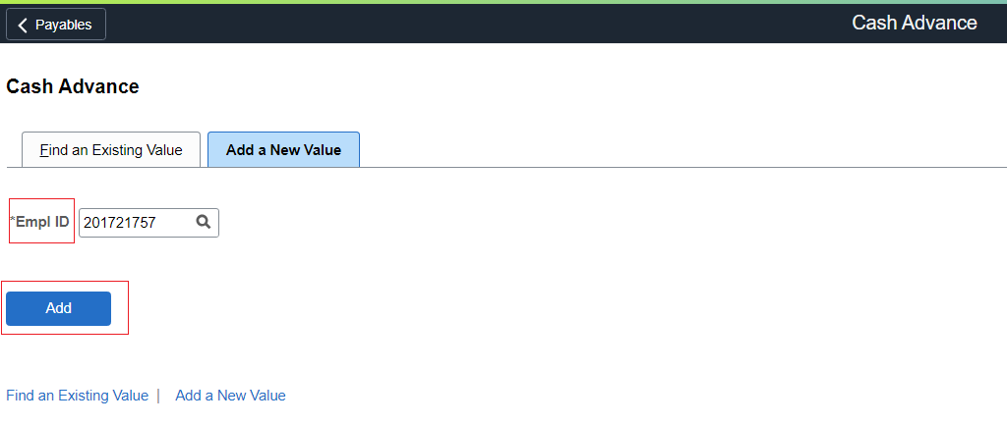

Please note that you do not need to separate your lines by meal or day; one line total is sufficient.
Business Purpose – Select from the drop down menu
Advance Description – Please make it the same as your Travel Auth Description
Source – System Check
Description – Any description here is good (total meal expenses, hotel advance, etc)
Amount – The total amount requested
Accounting Details – All cash advances regardless of fund, need to use the same clearing account code.

- Check the box and select Submit Cash Advance.

- If there are no errors in the cash advance, you will see a pop-up asking to confirm. Select OK.

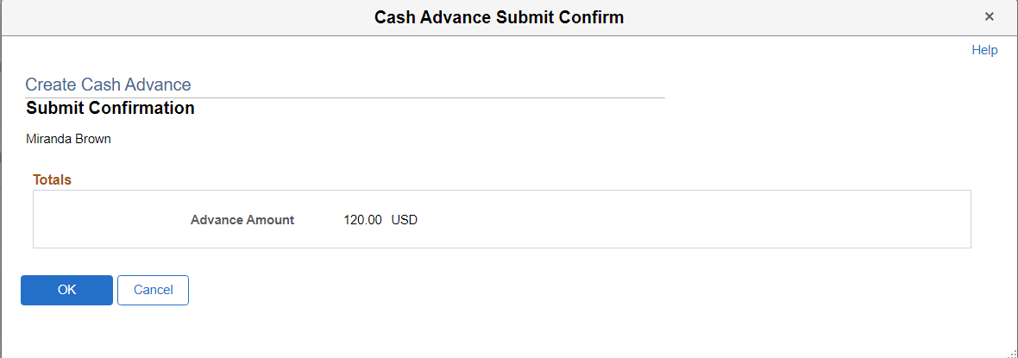

Success! You are done submitting your cash advance. You will need to go back and finish submitting your Travel Authorization.
Returning Unused Cash Advance Funds

If you request a cash advance but do not use any or a portion of it, you have two options:

- You may apply the cash advance to a future expense report for a different trip within the same fiscal year.

- Use the cash advance return form below:
  - Return of Cash Advance
  - Fill out the form and bring to cashiers with, preferably, a check or cash. Make sure you receive a receipt and send a signed copy of this form back to travel@skagit.edu

