
Skagit Valley College Expense Report Creation

How to Create an Expense Report

Section 1 Travel-Related Expenses
This guide will show you how to create an expense report from a travel authorization (TA) in Part 1 and, in Part 2, how to create one for travel-related expenses that do not need a travel authorization. An expense report is a college employee’s method of being reimbursed for approved expenses they paid out of pocket. College employees can only be reimbursed for expenses incurred for work purposes. First, a few tips:
- Your screen may look different than the images you see in this guide. The number of tiles you see and the options you have on the menu will depend on your role at the college.
- The SVC IT Helpdesk, ITHelpdesk@skagit.edu, can help if you have problems with sign-in credentials, usernames, or passwords.
- The Travel Administrator, Miranda Brown, can assist you with errors or questions directly relating to filling out the Expense Report.

Section 2 Misc Report Information
- If you seek reimbursement for travel that includes an overnight stay or out of state travel, you must have a travel authorization (TA) completed in ctcLink before the first date of travel. If you do not have an approved TA, you will not be eligible for reimbursement. *
- If you are submitting an expense report for a same day/non out of state travel, a travel authorization is not necessary.
- Know your unique Report ID. The Report ID will be assigned after you submit. If you have a question or concern regarding your expense report, this will be the easiest way to find it.
- Each department is responsible for maintaining a record of their expense reports to avoid submitting duplicates.
- Attachments are required as backup documentation. Make sure to include any receipts, agendas, itineraries, or other backup documentation to justify expenses.
- Payment Type:
  - Employee - You paid for it and plan to seek reimbursement.
  - PCard - You paid using a purchase card and will not seek reimbursement (typically only applies to registration, hotel, and airfare; purchase cards cannot be used for all travel expenses).
  - Prepaid - Paid for by college AP (Accounts Payable) staff via check
- Default Location:
  - If your location is not populating, email Miranda to verify or use the per diem location for another city in the same county.
- Expense Status:
  - Pending – The report has not been successfully submitted or was sent back by an approver.
  - Submitted – The report has been submitted but no approvals have been started.
  - Approvals in Process – At least one person in the queue has approved.
  - Approved – All approvers have approved.
  - Staged – It has been staged for payment.
  - Paid – A check has printed or an ACH dispatched.
  - Denied – One of the approvers denied the report.

Section 3 Directions

Part 1: Creating an Expense Report from a Travel Authorization

Steps 1–8 show you how to navigate to the page to begin creating an expense report from an existing travel authorization. If you are familiar with ctcLink navigation, here is the shorthand version: From the ctcLink Gateway, click FSCM (or Financials Self-Service) > NavBar > Navigator > Employee Self-Service > Travel and Expenses > Expense Reports > Create/Modify

- Log in to ctcLink.
- Click FSCM (Financial Supply Chain Management) from the top of the window or Financials Self-Service on the left navigation.
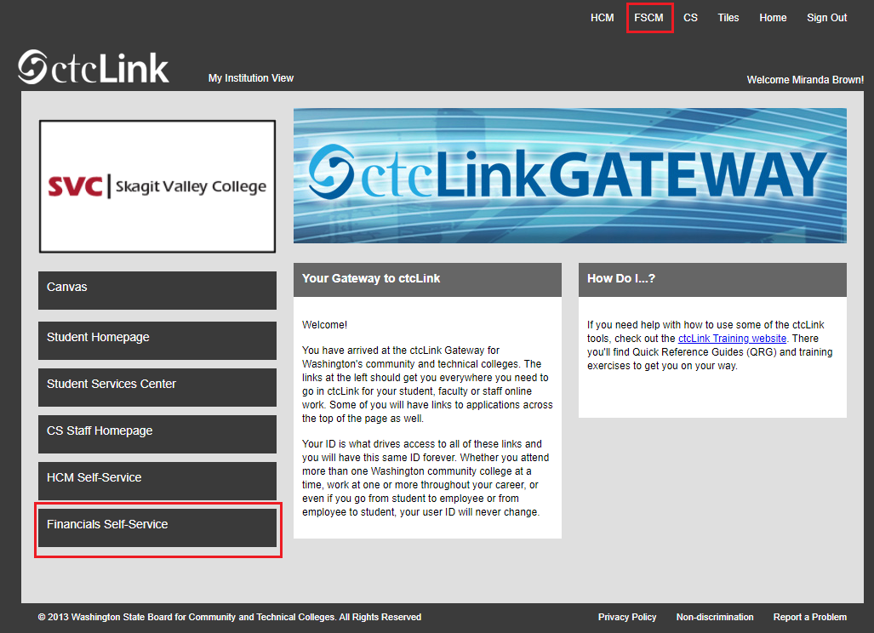

- Click the Navigation Bar (NavBar) button in the top right corner — indicated by the compass icon — to view the NavBar tiles.

The NavBar tiles will display. Click the Navigator tile.
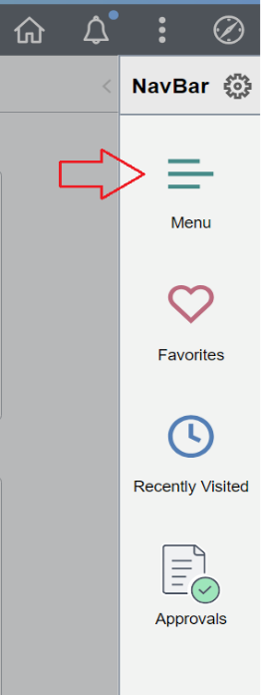
- The Secondary Level Content menu will display. Click Employee Self-Service.

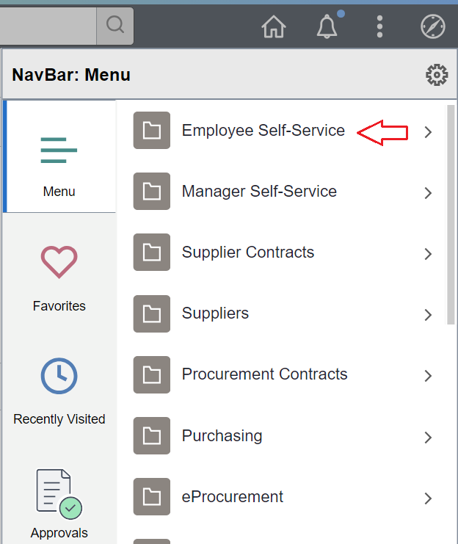
- The Employee Self-Service menu will be displayed. Click Travel and Expenses.
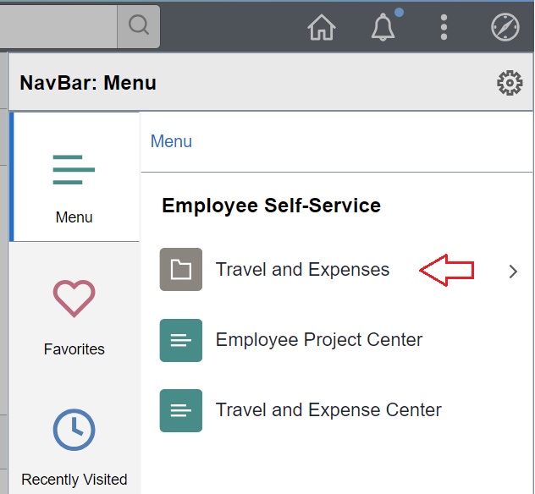
The Travel and Expenses menu will display. Click Expense Reports.
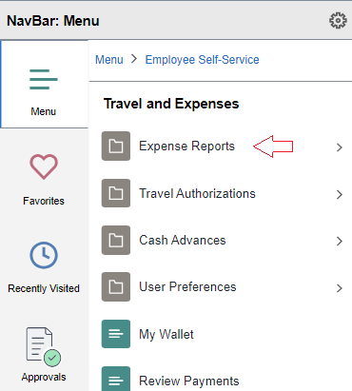
The Expense Reports menu will be displayed. Click Create/Modify.
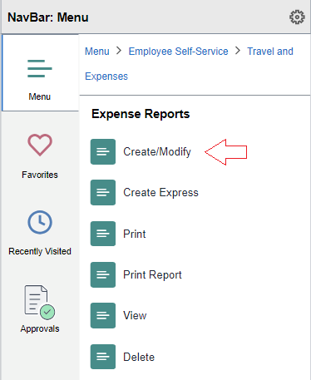
- The Expense Report page will display. With the Add a New Value tab selected, enter your Empl ID, which is another name for your ctcLink ID. Click the Add button.

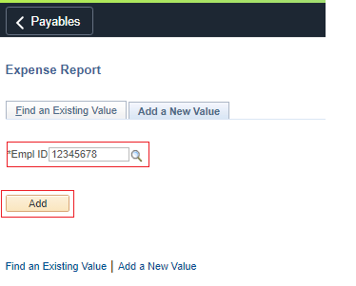

- The Create Expense Report page will be displayed. From the Quick Start drop-down menu, select A Travel Authorization. Click Go. The expense report fields will automatically populate from your travel authorization. This will save you time in completing your expense report.
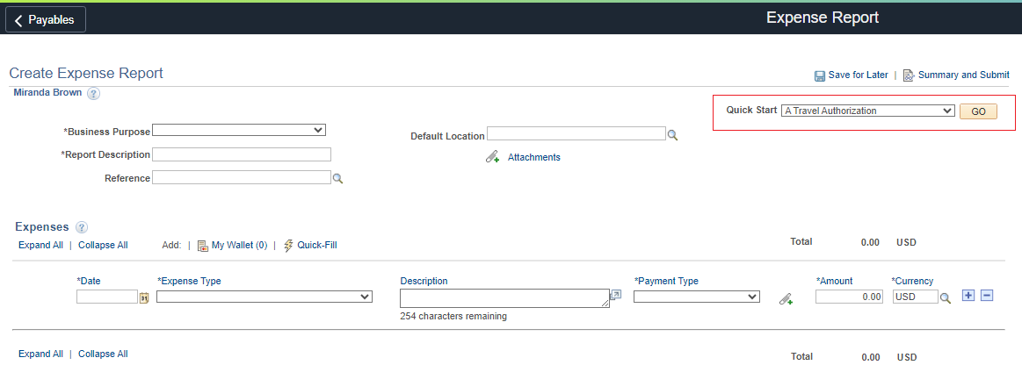

- Select the Travel Authorization you want to associate the Expense Report with.
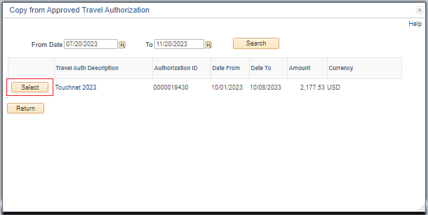

- Review all line items in the Expenses section to make sure all expenses are included. And make sure that you have attached receipts for those expenses requiring them.
  - Meals and mileages do not require receipts but cannot surpass the allotted amount as defined by the General Services Administration (GSA).
  - Each meal will require a new expense line. For example, you will need three lines for breakfast, lunch, and dinner.
  - Each night in a hotel will require a separate expense line. And hotel tax will require a separate expense line (you can group all tax for all nights in one expense line).
  - If you have filled in the Default Location, the per diem — or daily expense allowance — will automatically populate for certain types of expenses such as meals and hotels. If no location is provided, you will need to provide documentation from GSA proving the amount you have entered is within per diem. If your hotel expenses exceed per diem, you will need to attach the Maximum Lodging Exception Form and use Hotel Misc No Per Diem.
- To add an expense line not included in your Travel Authorization, click the Add a New Row [+] icon on the right side of the row.
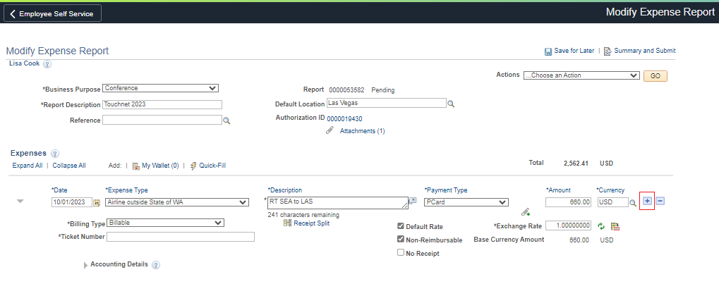

- When you are ready to submit, click on the Summary and Submit link in the top right corner.
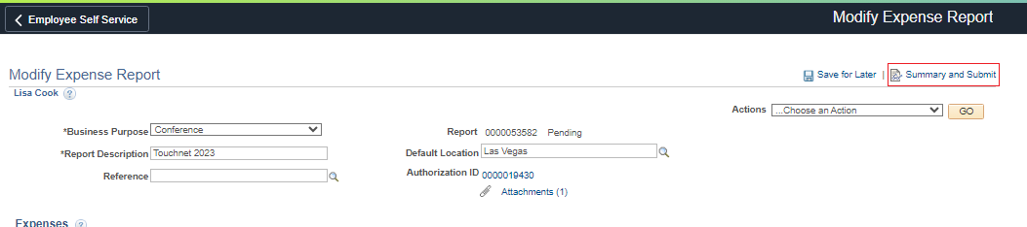

- Review the information for accuracy and check the box under Amount Due to Employee. Click the Submit Expense Report button.
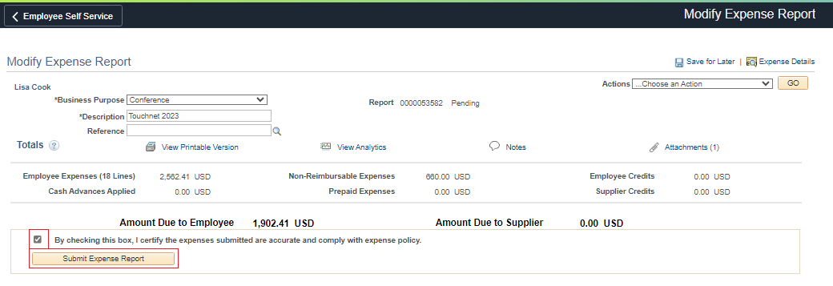

- If you had errors, it would bring you back to the expense details page and show red flags for the expense lines with errors. Fix the errors and attempt to resubmit.
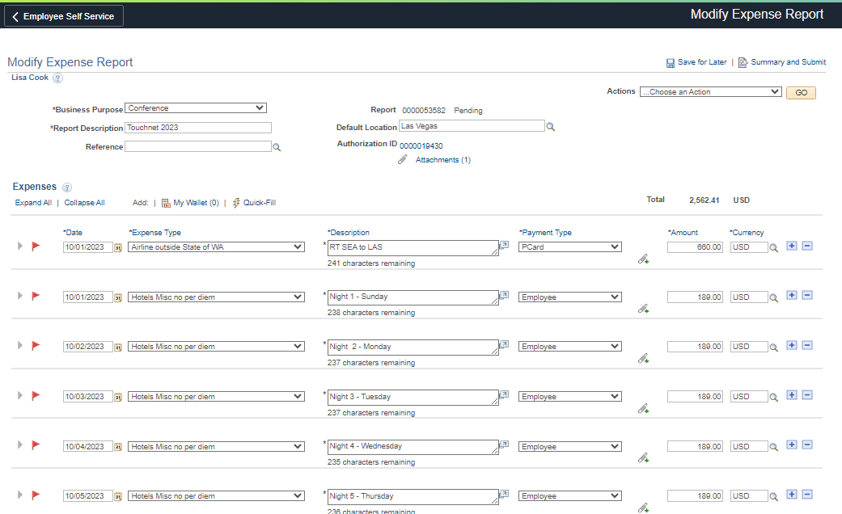
- If there were no errors, you will see the following pop-up. Select OK
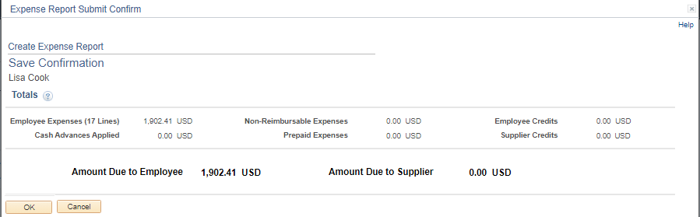
- The expense report is now submitted and is in the workflow. The budget manager will need to approve the request before it moves on to the next steps for processing.
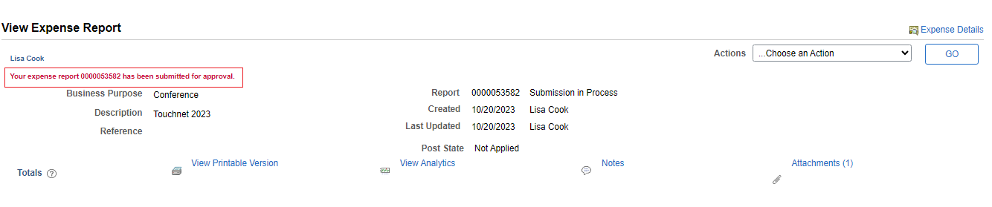

Part 2: Creating an Expense Report Without a Travel Authorization

To begin, follow steps 1-6 in Part 1 and return here to pick up with step 15.
- The Create Expense Report page will be displayed. Fill in the form header:
  - Business Purpose: Make a selection from the drop-down menu. You can choose whatever is appropriate.
  - Report Description: Be specific. Name the conference or reason for travel. If you are asking for reimbursement of mileage during a specific timeframe, then include the date range, such as “Mileage April 2021.”
  - Default Location: Field is not required, but helpful if all your expenses will take place in one location. Use the Look Up icon (magnifying glass) to see a list of locations.
  - Reference: Field is not required.
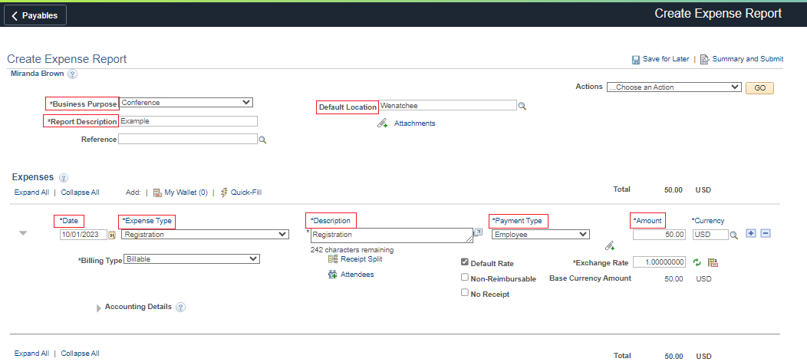
- Complete the Expenses section:
  - Date: This is the date the expense incurred.
  - Expense Type: From the drop-down menu, select a category.
  - Description: Enter a brief description. For mileage, include key information, such as where you traveled to and from as shown in the example below. If you are using a lodging exception.
  - Payment Type: Select Employee/P-Card/Pre-paid from the drop-down menu
  - Amount: The Amount field will not be available for transportation mileage. It will automatically calculate after you fill in the Transportation ID and Miles fields, explained in the next step.

- If you need to add another expense, click the Add a New Row [+] icon on the right side of the row and complete the expenses row again.
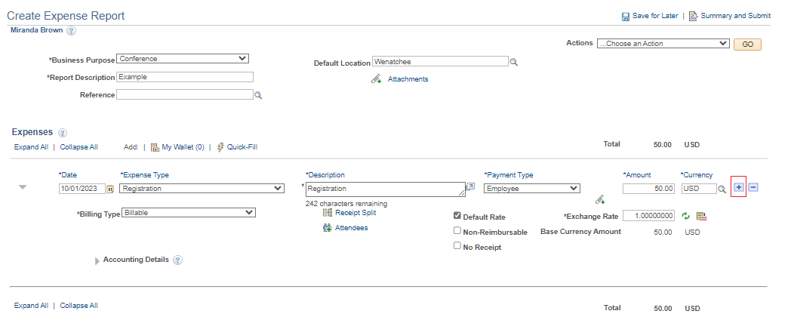
- Under Accounting Details fill in the following required fields:
  - GL Unit: Always “WA040”
  - Oper Unit: Always “7040”
  - Fund
  - Dept
  - Class
  - State Purpose: This will almost always be N or “Null” unless the expense is related to IT — such as software, hardware, IT training, cloud services or subscription, or other IT-related items — the State Purpose field must be either Y or X. For questions, contact IT and/or the Finance office.
If your expenses are related to a grant, then also fill in these additional fields:
  - PC Bus Unit
  - Project
  - Activity
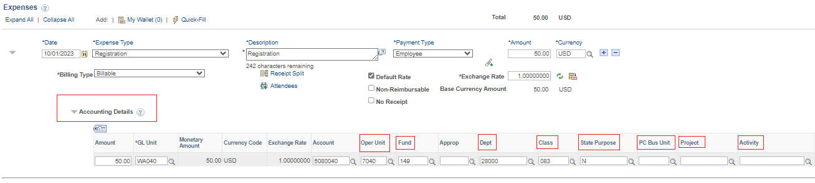

- When you are ready to submit, click on the Summary and Submit link in the top right corner.
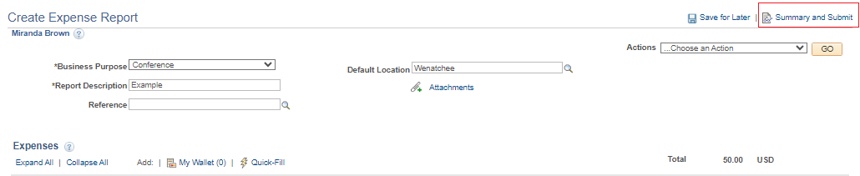

- Review the information for accuracy and check the box under Amount Due to Employee. Click the Submit Expense Report button.
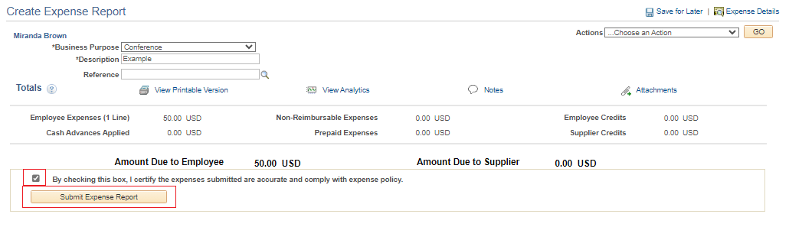

- If you had errors, it would bring you back to the expense details page and show red flags for the expense lines with errors. Fix the errors and attempt to resubmit.
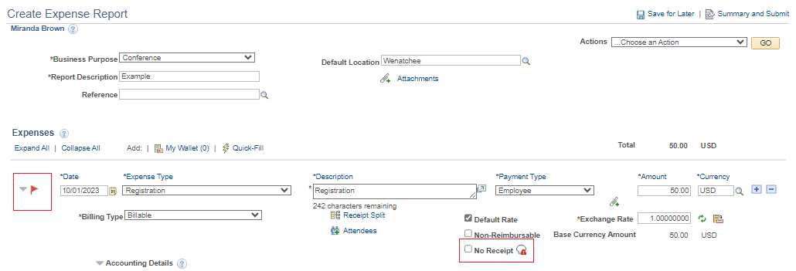
- If there were no errors, you will see the following pop-up. Select OK
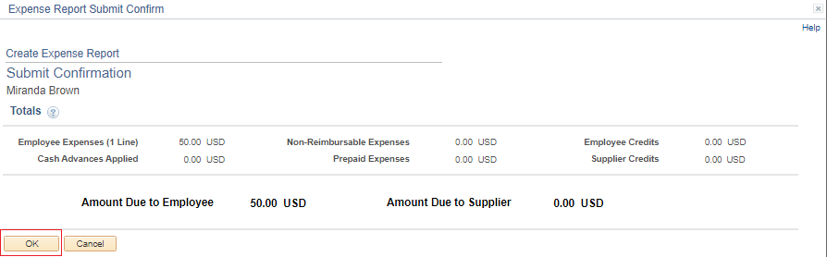
- The expense report is now submitted and is in the workflow. The budget manager will need to approve the request before it moves on to the next steps for processing.

Other Notes About Expense Reports

If you forget to associate with your Travel Authorization, you can go back in and do it afterwards.

By associating your Travel Authorization with your expense report, it will release the encumbrance from your Travel Authorization and only include actual expenses incurred on a budget report. This is especially important for Grants who need to track their monies to the dollar. It is also good accounting practice and will reduce the number of lines that show up on my end of year report.

Adding an Attachment

You will need to add receipts, agendas, etc., to substantiate your travel and expenses. Click the Attachments link either at the top of the page or directly to the applicable expense line.
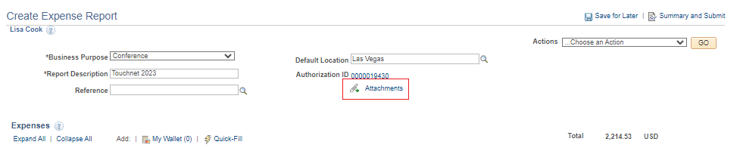
- Select Add Attachment

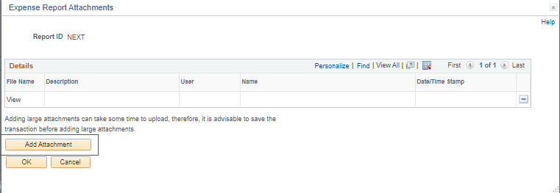
- Either drag and drop a file or Choose File. Select Upload.
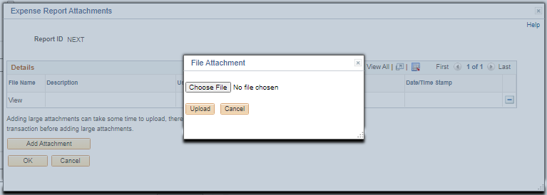

- Either repeat the upload process for multiple files or select OK
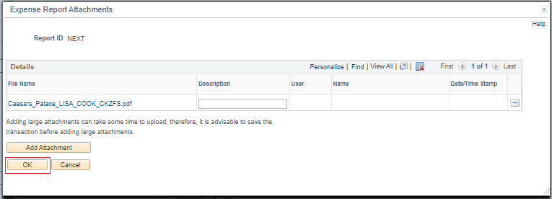

Mileage

First, you will need to create a vehicle in your profile (or make sure you have one). You only need to do this once unless you need to add a second/third vehicle.

NavBar > Navigator > Employee Self Service > Travel and Expenses > Review/Edit Profile​

- Navigate to the 'Transportation Information' tab​
- Enter the information in the red boxes​
- Your transportation ID can be anything: Make/Model, CAR, TRUCK, POV​
- Type will be AUTO​
- Date Acquired can be approximate​
- Status Date should be same as Date Acquired​
- SAVE

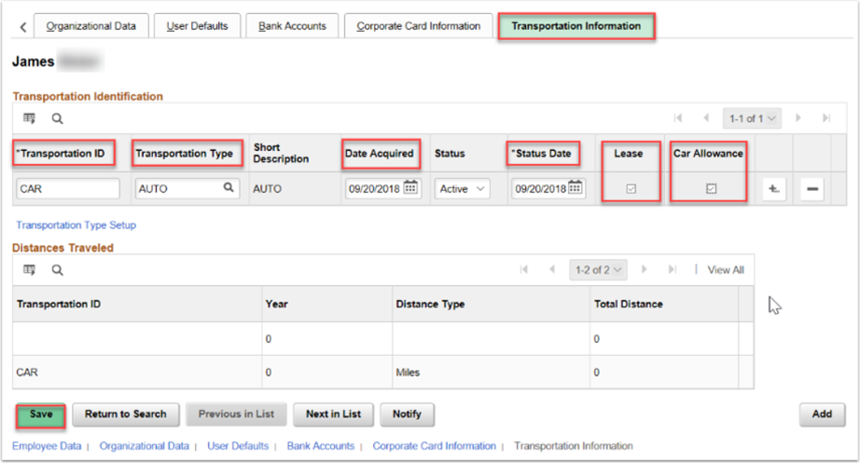

Once in your Expense Report, you will need to select your Transportation ID from the drop-down, enter total Miles, and put your to/from location in the Description.