
Skagit Valley College Travel Authorization Creation

How to Create a Travel Authorization
This guide will show you how to create a travel authorization (TA). A TA is required as prior approval before any college-sponsored travel can occur. A TA is not required for virtual conferences where no travel occurs or for same day travel. First, a few tips:
- Your screen may look different than the images you see in this guide. The number of tiles you see and the options you have on the menu will depend on your role at the college.
- The SVC IT Helpdesk, ITHelpdesk@skagit.edu, can help if you have problems with sign-in credentials, usernames, or passwords.
- The Travel Administrator can assist you with errors or questions directly relating to filling out the TA.

Know Before You Go
- Know your unique Authorization ID. The Authorization ID will be assigned after you save/submit. If you have questions or concerns regarding your TA, this will be the easiest way to find and resolve it.
  - Document Status Meanings
    - Pending - Saved but not submitted
    - Submitted - Submitted successfully
    - Approvals in Process - Someone has approved, but not everyone
    - Approved - All required approvers have approved
- Attachments are required as backup documentation. Make sure to include any booking confirmations, agendas, itineraries, or other backup documentation to justify expenses/estimates. To create electronic versions, you can take a picture with your phone and email it to yourself as a JPEG or PDF.

Payment Type:
  - Employee - You paid for it and plan to seek reimbursement (applies to those using corporate cards).
  - PCard - You paid using a purchase card and cannot seek reimbursement (only applies to registration; purchase cards cannot be used for travel expenses).
  - Pre-paid - Will be paid for via check by the college AP (Accounts Payable) staff

Default Location:
  - If your location is not populating, email Miranda Brown to verify or use the per diem location for another city in the same county.
  - Per Diem Rates:
  - https://www.gsa.gov/travel-resources (US per diem rates)
  - Per diem rate tables | Office of Financial Management (wa.gov) (WA State per diem rates)
  - U.S. Department of State | Home Page (Foreign per diem rates)
  - Per Diem Rates (Hawaii & Alaska)

Frequently Asked Questions

Do I need a new expense line for every night in a hotel and every meal?

Yes. This will make it easy and quick for you to create the Expense Report (ER) when you return. Think of this as doing most of the work in the front half of the process.

Do my expense estimates need to be exact? Can I still be reimbursed for amounts above the estimate?
This is just an estimate, so no, expenses do not have to be exact. Yes, you can be reimbursed for amounts that exceeds the estimate within reason.

What do I do about hotel tax?
You do not need to include hotel tax in your TA, but it will be required in your ER if you are requesting reimbursement for it. Tax can either be a single expense line or a new expense line for each night in the hotel. See Quick-Fill above for tips on adding a range of dates to an expense type.

What if a purchase card was used for registration or other expenses? Do I need to include it in the TA?
Yes, and use PCard as the payment method so that we know it is a non-reimbursable expense.

Directions
Steps 1–8 show you how to navigate to the page to begin creating or modifying a travel authorization. If you are familiar with ctcLink navigation, here is the shorthand version: From the ctcLink Gateway, click FSCM (or Financials Self-Service) > NavBar > Navigator > Employee Self-Service > Travel and Expenses > Travel Authorizations > Create/Modify

- Log in to ctcLink.
- Click FSCM (Financial Supply Chain Management) from the top of the window or Financials Self-Service on the left navigation.
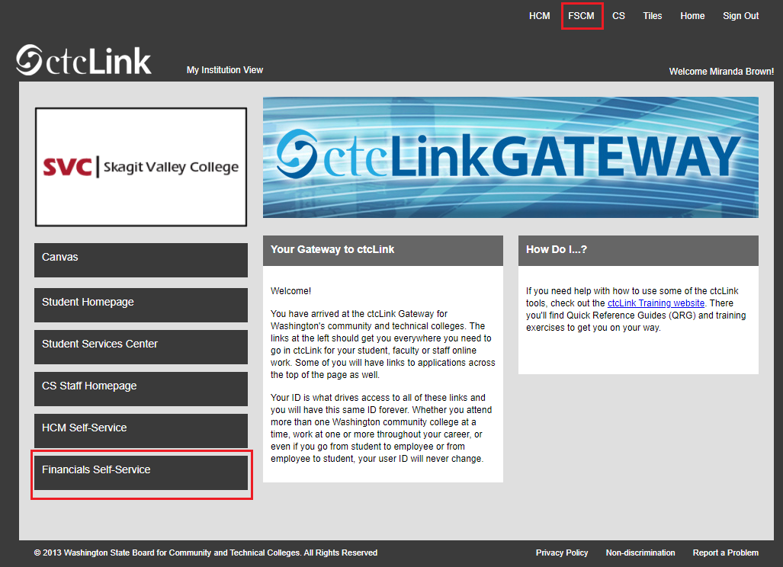

- Click the Navigation Bar (NavBar) button in the top right corner — indicated by the compass icon — to view the NavBar tiles.
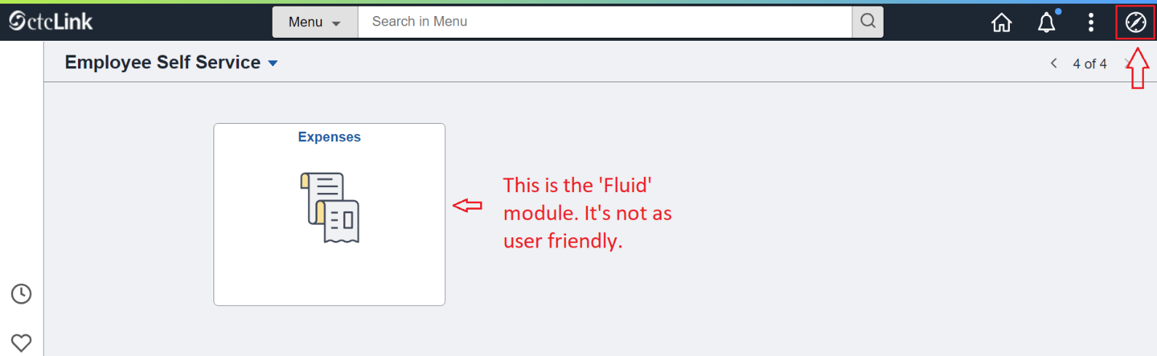
- The NavBar tiles will display. Click the Menu tile.
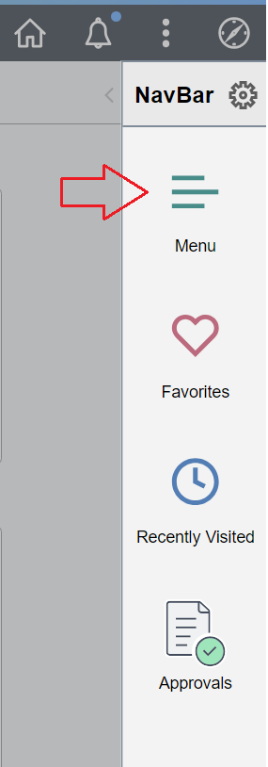
- The Secondary Level Content menu will display. Click Employee Self-Service.
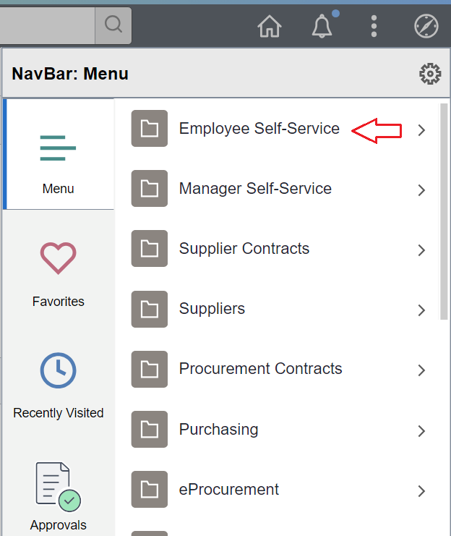
- The Employee Self-Service menu will be displayed. Click Travel and Expenses.
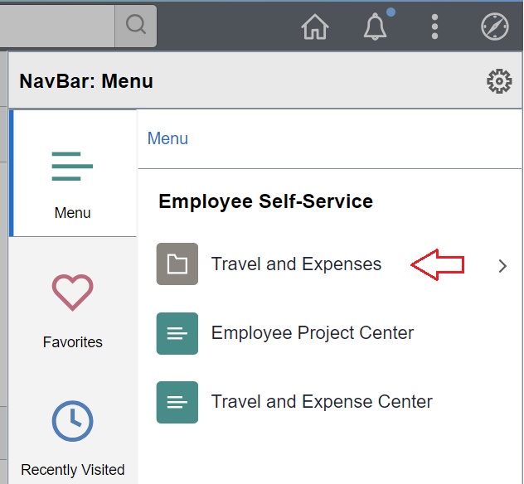
- The Travel and Expenses menu will display. Click Travel Authorizations.
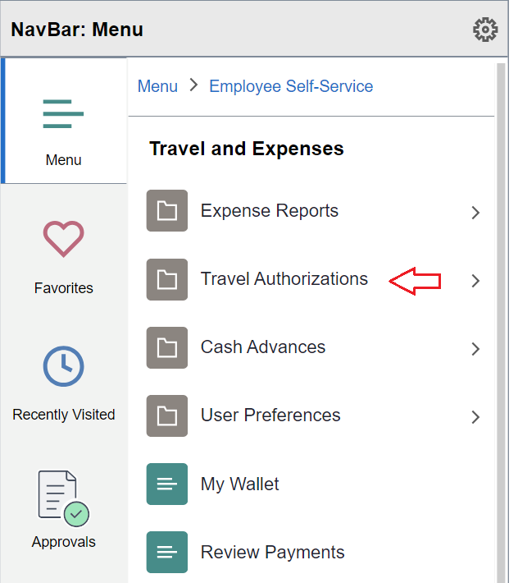
- The Travel Authorizations menu will be displayed. Click Create/Modify.
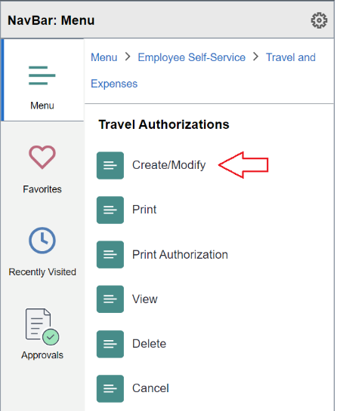
- The Travel Authorization page will be displayed. With the Add a New Value tab selected, enter your Empl ID, which is another name for your ctcLink ID. Click the Add button. (If you have previously created the TA and need to continue working on it, select the Find an Existing Value tab and search for it.)

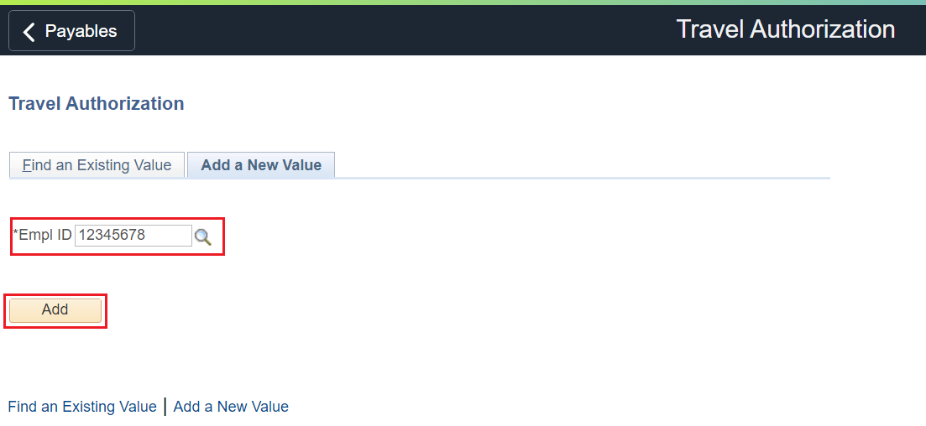
- The Create Travel Authorization page will be displayed. Fill in the form header:
  - Business Purpose: Make a selection from the drop-down menu. You can choose whatever is appropriate.
  - Description: Be specific. Name the conference or reason for travel.
  - Default Location: Field is not required, but helpful if all your expenses will take place in one location. Use the Look Up icon (magnifying glass) to see a list of locations.
  - Date From: Enter a date or use the Calendar Date icon to select the first day of travel. TA must be created prior to the first day of travel.
  - Date To: Enter a date or use the Calendar Date icon to select the last day of travel.
  - Reference: Field is not required.

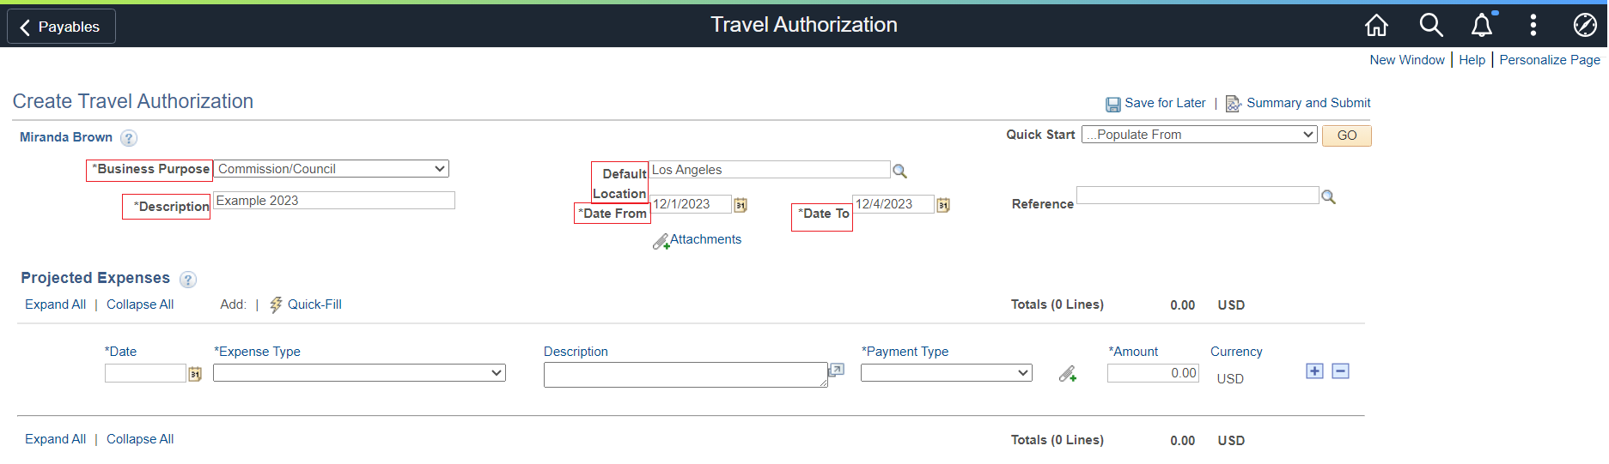

- Fill in the Projected Expenses section. You will need an expense line for each item. For example, each meal will require its own line. And each night in a hotel will require a separate line. Hotel tax will also be a separate line. While you do not have to fill out the hotel tax in the TA, it will be required for the Expense Report (ER).
  - Date: Enter a date or use the Calendar Date icon to select a date for the line item.
  - Expenses Type: Use the drop-down menu to select the type of expense.
  - Description: Fill in a description of the expense.
  - Payment Type: Use the drop-down menu to select.
  - Amount: If you have filled in the Default Location, the per diem — or daily expense allowance — will automatically populate for certain types of expenses such as meals and hotels. The Amount field will not be available for transportation mileage.

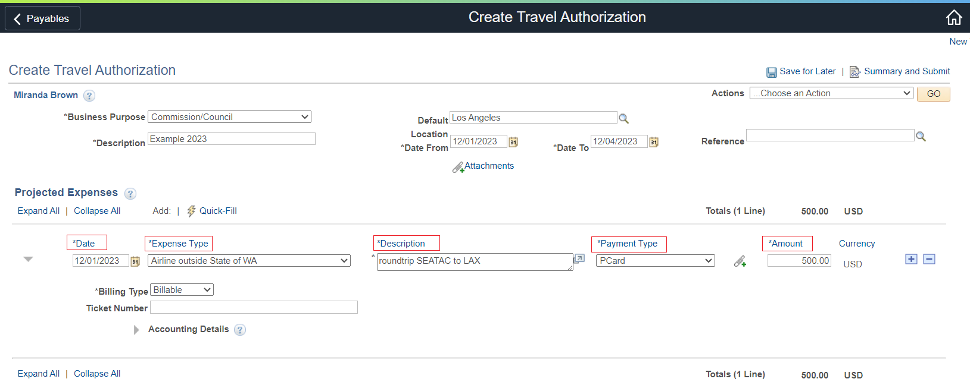

- After you have entered a line item, the Billing Type section will display. The fields you see — and will need to complete —
will depend on what you have entered in the Expense Type field.
- Once you have entered your first line, you can setup up default accounting. This is recommended if you have multiple lines to enter.
  - In the upper left corner, select Default Accounting from the Actions drop down. Select GO.
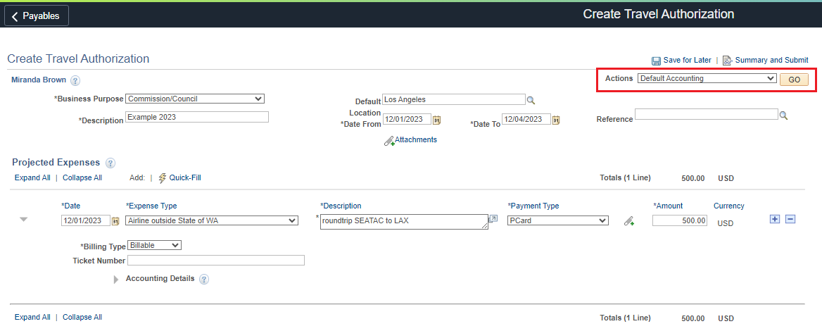
- Fill in the following required fields:
  - GL Unit: Always “WA040”
  - Oper Unit: Always “7040”
  - Fund
  - Dept
  - Class
  - State Purpose: This will almost always be N or “Null” unless the expense is related to IT — such as software, hardware, IT training, cloud services or subscription, or other IT-related items — the State Purpose field must be either Y or X. For questions, contact IT and/or the Finance office.
If your expenses are related to a grant, then also fill in these additional fields:
  - PC Bus Unit
  - Project
  - Activity

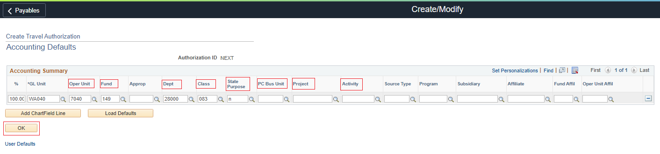

--------------------------------------------------------------------------------------------------------

- To add an expense line, click the Add a New Row [+] icon on the right side of the row or use the Copy Authorization Lines technique mentioned in the Helpful Hints section below.
- After all projected expenses have been entered, either click on Save for Later to submit another time or Summary and Submit link at the top right of the page.

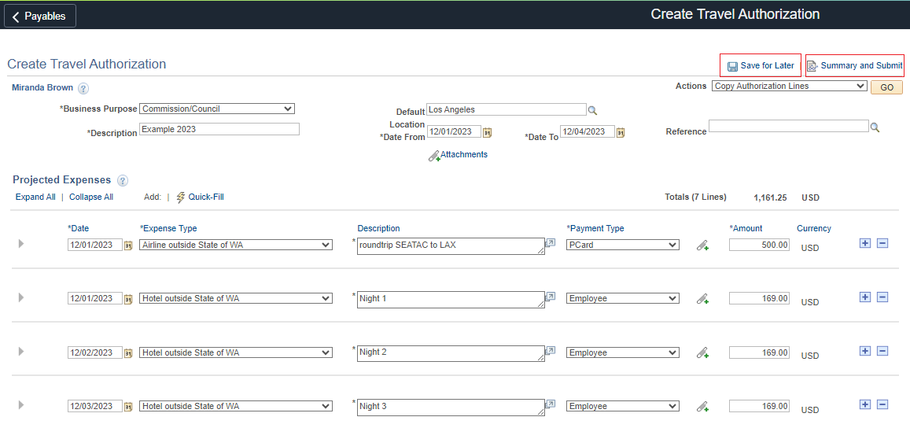
- Check the box and click the Submit button.
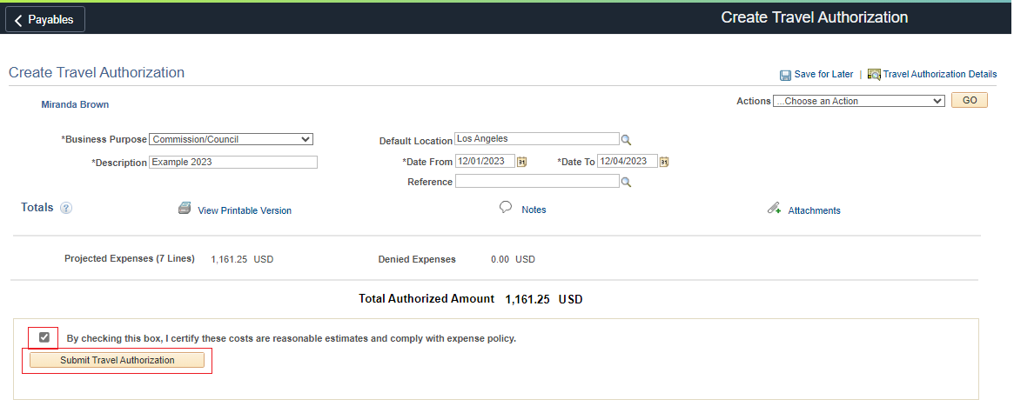
If you had an error in your Travel Authorization, it would bring you back to the expenses page and show red flags as shown below.
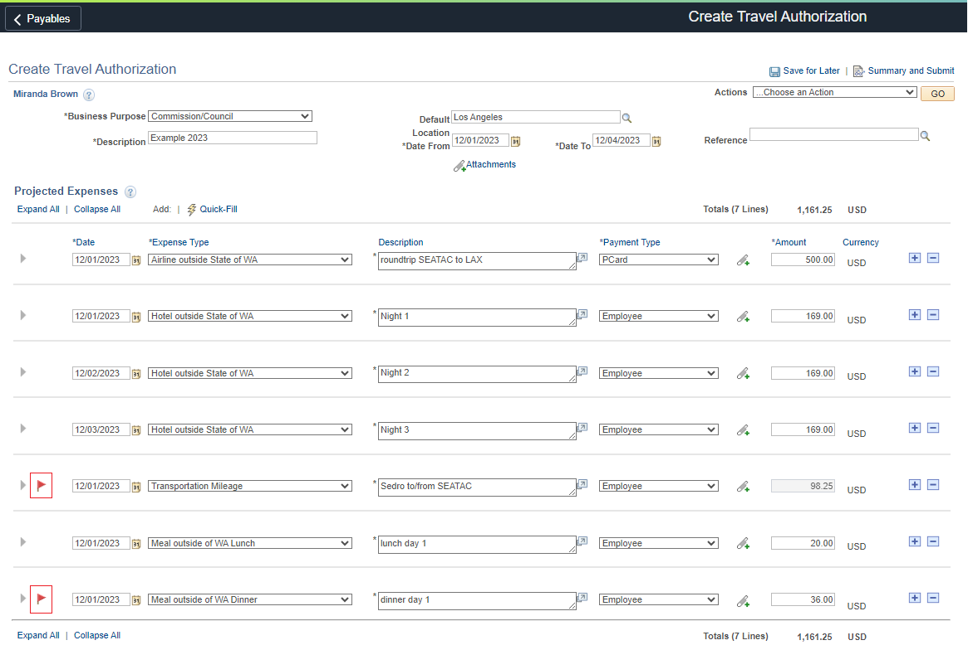
Fix the errors and try submitting again.

- If there are no errors, the following pop-up will show. Click OK.
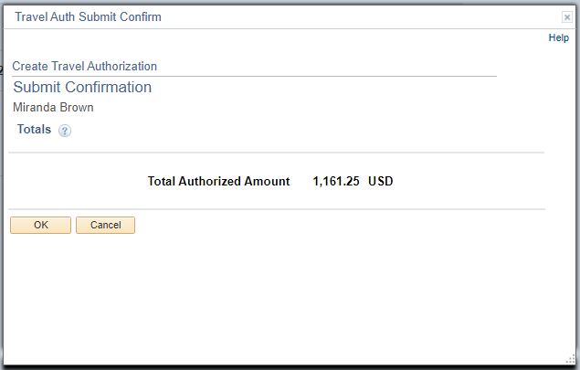

Your Travel Authorization has been successfully submitted. Keep an eye out for approvals. If they are taking a while, view the approval flow to see whose queue it is waiting in.

View/Withdraw Travel Authorization
- Navbar – Employee Self Service – Travel and Expenses – Travel Authorizations – View

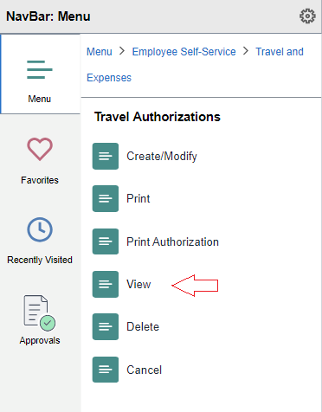

- You can either view the approval flow or Withdraw if you forgot to add an expense line.

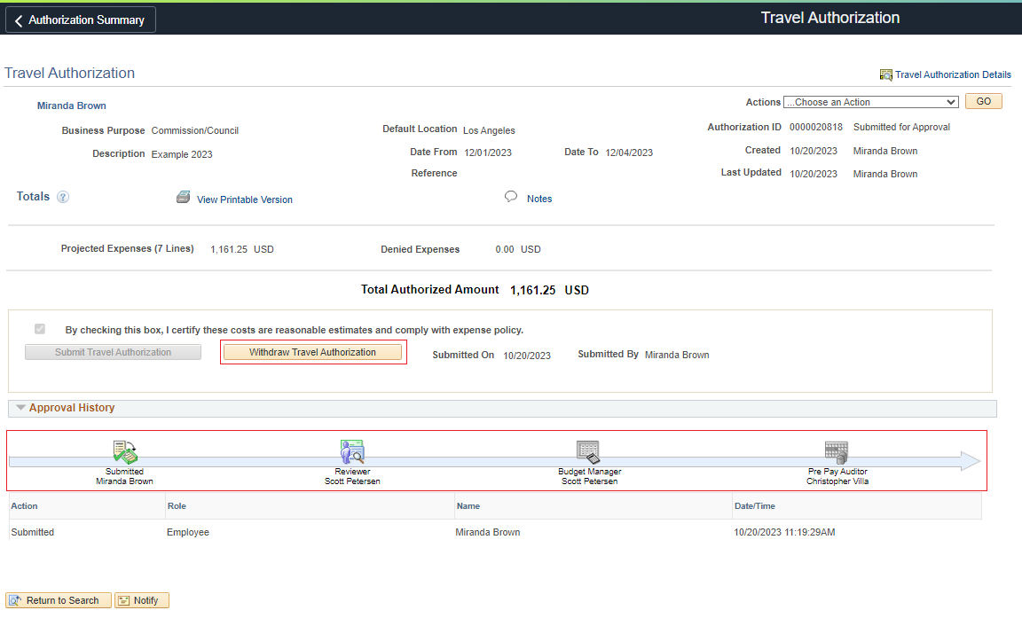

Helpful Hints

Copy Authorization Lines
- Using the Actions drop down – select Copy Authorization Lines. Click GO.
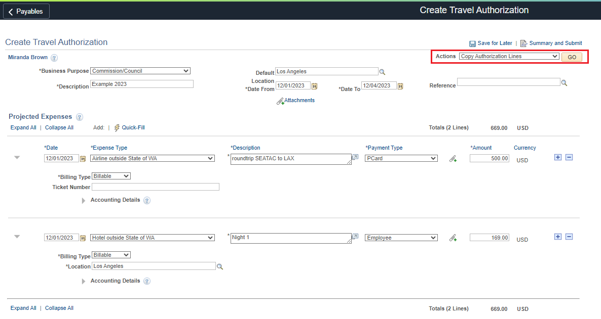
- Select the Copy to a Range of Dates button.
- From Date = this will be the date after the date of line you are copying
- To Date = for hotels, this is the date before you check out, otherwise it is the last date you need the line copied to
- Select the line you want copied (you can select multiple)
- Click OK
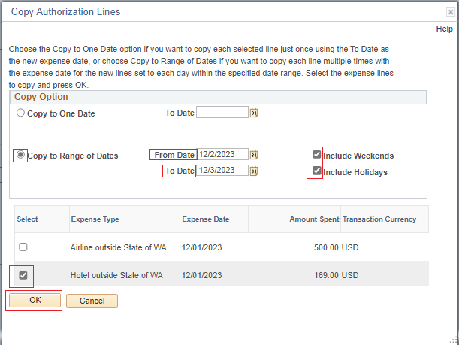

- Your lines will now be populated. Be sure to update the description if needed.
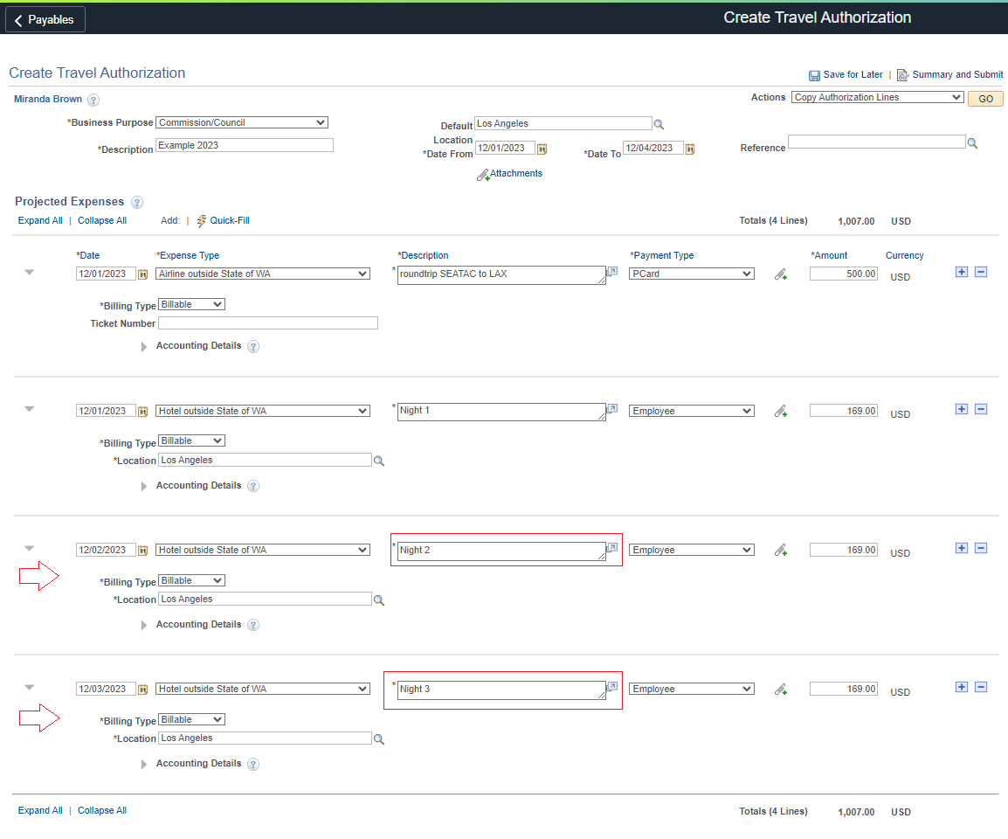

Quick-Fill

Instructions to come 😊

