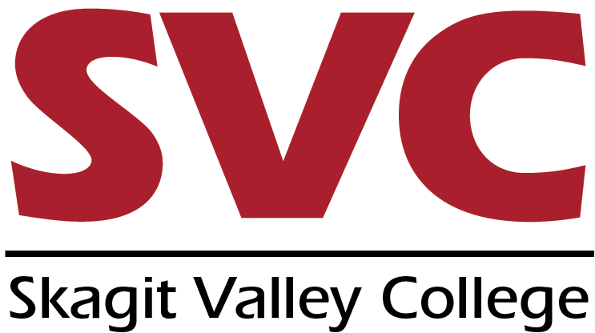
CTE DUAL CREDIT
Course Content and Assessment Review Form

High School __________________________________ Date_________________
CTE Instructor ________________________________ SVC Faculty Liaison_________________
High School Course Name ______________________ SVC Course Name _________________
SECTION I: TO BE COMPLETED BY THE HIGH SCHOOL CTE INSTRUCTOR
Please complete section I and return this form to dualcredit@skagit.edu with a copy of the updated course syllabus and a sample assessment tool. The SVC course learning outcomes are available via the “catalog course search” feature at https://www.mysvc.skagit.edu/cat_search2.asp. Assessment methods may include but are not limited to: written exam; research paper; project completion; demonstration; or oral presentation.
SVC Course Outline Learning Outcome | Assessment Method
SECTION 2: TO BE COMPLETED BY THE SVC FACULTY LIAISON
SVC course learning outcomes are listed in the CTE course syllabus: Yes ☐ No ☐
Pre-requisites and content are equivalent with the SVC course: Yes ☐ No ☐
Assessment methods and grading policies are equivalent in determining student achievement of SVC learning outcomes and core competencies: Yes ☐ No ☐
Course articulation recommendation:
☐ Approve
☐ Approve with the following revisions:
☐ Not approved due to the following:
Faculty Liaison Signature: __________________________________________ Date:____________
Dean Approval: Yes ☐ No ☐ Comments:
Dean Signature: __________________________________________________ Date:____________
Sample Submissions for Section 1:
BUS 112
Course Learning Outcome | Assessment Method
Analyse consumer spending and savings patterns. | Written Exam
Increase income | Written Exam
Protect Assets | Written Exam
Invest properly | Written Exam, FBLA Stock Market Game
Reduce taxes | Written Exam, Complete 1040 EZ
Plan for retirement and estate transfer | Written Exam, project impact of mortgage on retirement

AT 101
Course Outline Learning Outcome | Assessment Method
- Understand and apply safety practices while working in an industrial shop. | Written exam, demonstration, oral presentation  with Syllabus and tool use.
- Perform basic maintenance on a variety of shop equipment | Tool and equipment safety checks
- Safely use power and hand tools | Written exam; research paper and handout
- Correctly identify and measure metric and standard hardware | Written tool identification demonstration handout with a written exam.
- Perform a basic vehicle safety inspection | Written Preventive Maintenance form designed for project completion
- Perform basic vehicle maintenance including oil changes, tire rotation, and fluid and filter inspection | Research paper, shop lab check off project completion sheet
- Access and navigate electronic repair information | Oral presentation, computer project completion with Prodemand software

