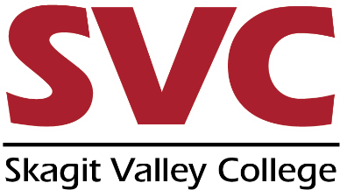
SKAGIT VALLEY COLLEGE
CTE DUAL CREDIT
SYLLABUS REVIEW FORM

SVC Course:_____________ CTE Instructor:___________________________ High School:_________________
Note: This document is for reference purposes for CTE high school teachers and must be completed by the SVC Faculty Liaison. Items in Bold type are required, other items are strongly recommended.
Elements to be included | Yes or No | Comments
SVC and High School course names and numbers,
title, quarter/semester, and year.
Language indicating that the class is eligible for CTE Dual Credit through SVC and the required steps to earn credits.
Statement explaining benefits and responsibilities of enrollment in CTE course (see page 2 for language).
Course meeting time and location/room.

Instructor name and contact information.

Course summary and welcome statement.

Course pre-requisites (if any).

Required materials (textbooks, calculators, etc.).

Learning outcomes (as stated in course outline) and core competencies.

Classroom behaviors/ expectations.

Attendance policy.

Calendar of assignments, due dates, quizzes and exams
(Including statement that these are tentative/subject to change).
Late work policy.

Grading policy includes both grading breakdown (assignments , participation, tests) and final grade.
Date, location and time of final or ‘NO FINAL’.

Student Academic Honor Code (see page 2 for language).

CTE Dual Credit logo.

Logical organization / information easy to find and understand.

Example CTE Benefits and Responsibilities Statement:
Career and Technical Education (CTE) provides students in approved high school courses the opportunity to earn college credit from Skagit Valley College. Students enrolled in SVC CTE are afforded all SVC student rights and responsibilities. Grades earned though CTE will be transcripted by Skagit Valley College and become part of the student’s permanent college record.
Example Academic Honor Code statement:
Academic Honor Code All students of Skagit Valley College are responsible for knowing and adhering to the Academic Honor Code of this institution found at http://www.skagit.edu/honorcode. Violations of this code include: cheating, plagiarism, aid of academic dishonesty, fabrication, lying, bribery, and threatening behavior. All incidents of academic misconduct are reported to the student conduct officer. Students found to be in violation of the Academic Honor Code are subject to academic consequences up to and including failure of the course. Students may also be subject to college disciplinary sanctions up to and including expulsion from the College.
Link to SVC Catalog with Course Numbers, Titles, and Outcomes:
https://www.mysvc.skagit.edu/cat_search2.asp
CTE Dual Credit Process and Logo:
Students may earn college credit by completing the following:
- Be enrolled in the required high school class.
- Register for CTE Dual Credit articulated course through SERS (www.ctesers.org) during the same academic year the high school class is completed. If a series of courses are involved in the articulation, students register for credit during the same academic year the last course in the series is completed. Students cannot earn “retroactive credit” for courses taken in previous years.
- Earn a grade of ‘B’ (3.0) or better in all courses required under the articulation agreement.
- Complete all required skills as identified on the competency profile.
Please note: if an exam or portfolio is required under the terms of this agreement, students must receive a passing score (determined by college or industry certification) to earn college credit (see competency list for requirements).
CTE Logo:

SERS Logo:

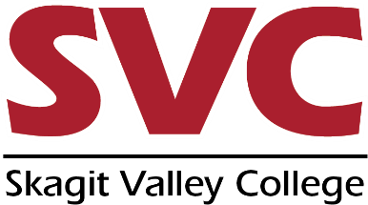
SVC Logo:

